Use case: “Check eligibility criteria”
- Actor: Student
- Precondition: student has logged in to the system.
- Main success Scenario:
- Student clicks check eligibility criteria in the menu bar.
- System displays a form requiring the student’s information such as: CGPA, Id card, family Income, monthly bills, siblings’ fee slips.
- After providing information the student will click on check.
- Then system will show that student is eligible for which scholarship (need based (if a student’s family has low income and are more members means student’s family can’t afford the fees or student is orphan then that student will be selected for need based scholarship) or merit based (if student has one of the highest percentage in the given program, then the student will be selected for the merit based scholarship)).
- Alternative flow:
- Student has been eligible for both scholarships so system will show both and student can fill form for both only if that student has not been approved for any scholarship.
- Student is not eligible so the system will show “not eligible” .
- Student is orphan so that student is eligible for need based scholarship, no need to provide the family income, monthly bills and sibling’s fee slips.
- Exception flow:
- The student filled a data in incorrect format, or some data is missing then system will highlight it so that student fills it correctly.
- System does not work properly due to server or internet issue.

- User story1(high priority):
As a student, I want to check my eligibility criteria so that I know which scholarship
I am eligible for.
- Acceptance criteria:
Given: I am on the home page.
When: I will click on check eligibility criteria then the form will be shown that I must fill.
Then: After filling the form there will be a option that says check eligibility after clicking that option the message will be shown that you are eligible for which scholarship, or you are not eligible.
- User story2:
As a student, I want to fill the form correctly and fully so that I can check eligibility criteria.
- Acceptance criteria:
Given: I will click the check option.
When: The system will highlight boxes, red indicating the inaccurate or missing information.
Then: I will fill correct information and fill the missing information
And will click check option then the message will be shown that you are eligible for which scholarship.
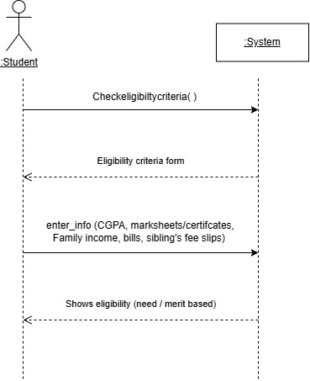
System sequence diagram:

